Bureau Veritas, CPS
ISTA Over packing Sample

Purpose of over packing the (ISTA) test sample:
Integrity of the sample within the packaging as well as the selling carton is evaluated during the ISTA testing. The goal is to ship the selling carton to the lab undamaged. Over packing the sell carton prevents / reduces the possibility of a sample arriving the lab damaged and effecting the ISTA result.

Over pack carton:
1. Over packing -
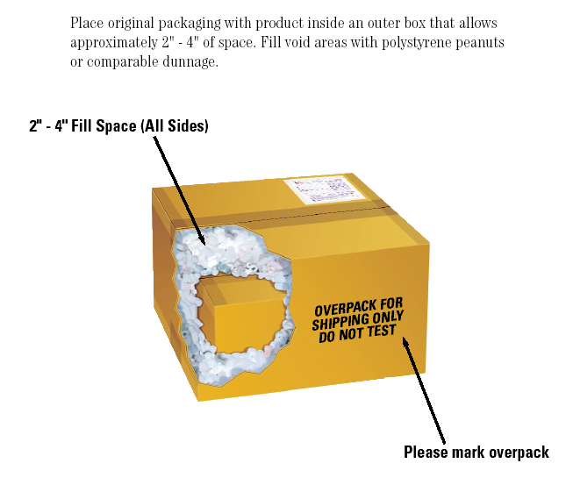

2. Attach the completed ISTA test request form to the outer most carton. Do not enclosed forms with the sample.
3. Send the over packed carton to the Bureau Veritas CPS lab indicated in
Test Request Form.

If the carton is not over packed, lab may assume the samples are for quality testing and open the carton. Once the carton is opened, it is no longer a viable ISTA test sample. New Samples will need to be submitted which delays the testing process.

4. Testing will begin the next day of when the sample was received.

